Science Highlight – August 26, 2011
First Results from EXO-200 P.C. Rowson

The EXO-200 experiment (EXO stands for “Enriched Xenon Observatory” and 200 for the total amount in kilograms of isotopically enriched xenon available) has released their first results – two-neutrino double beta decay has been observed in ¹³⁶Xe for the first time. This extremely rare nuclear decay process is expected within the standard model of particle physics, and has been previously seen in many other isotopes, but up until now only upper limits on the decay rate in ¹³⁶Xe were available. It was in fact puzzling that the process had not been previously observed, as theoretical predictions indicated a detectable rate. The EXO-200 result seems to have settled the issue by contradicting the older experimental results and confirming the calculations.
Many radioactive elements undergo ordinary “beta decay” (the emission of an electron and an anti- neutrino when a neutron in the atomic nucleus transforms itself into a proton) - a very small number of elements have isotopes that can also undergo “double-beta decay”, where single beta decay is energetically forbidden, but double beta decay is allowed. The half-life for double beta decay is typically > 10¹⁹ years, and hence can only be observed if one can gather together a larger number of atoms of the correct isotope, and observe them for a long time. In addition, due to the rareness of this process, it is critically important to control all sources of natural radioactivity and cosmic radiation unrelated to the double-beta decay itself (“backgrounds”), and the experiments built to search for double-beta decay must be very carefully constructed from “high-radiopurity” materials and are typically located deep underground.
In recent years there has been a flurry of activity in double-beta decay experiments, as physicists search for the as-yet-unseen process known as “neutrinoless double beta decay”. The intensified interest arises from the significance attached to the observation of the neutrinoless mode, and to the fact that neutrinos are now known to have a finite but undetermined mass, a necessary condition that makes this process possible. In neutrinoless double beta decay two betas (two electrons) are emitted without accompanying antineutrinos – a process not allowed in the standard model as it violates lepton number conservation. In fact, if the neutrinoless process is observed, one can conclude that neutrinos are their own antiparticles, an unanswered question dating from the 1930s with profound implications for particle physics and cosmology, and in addition one can deduce the value of an effective neutrino mass from the observed decay rate. A first step in the experimental program is the measurement of the two-neutrino mode half-life, as this allowed decay is a background for the neutrinoless mode search and must be understood. At the same time, this data assists the difficult calculations of the nuclear matrix elements that one needs in order to make the connection between the neutrinoless decay rate and the neutrino mass.
The EXO-200 apparatus is a time projection chamber, or “TPC”, filled with liquid xenon enriched to 80% in the 136 isotope (natural xenon contains ~ 9% of this isotope) placed in a cleanroom about half a mile underground at in the DOE-operated Waste Isolation Pilot Plant (WIPP) facility in New Mexico. The liquid xenon in this cryogenic device (operated at ~ 167K) serves as both the source of the decay and as the detection medium.
In a TPC a nuclear decay process (or radioactive background) manifests itself in the form of ionization and ultraviolet scintillation light caused by the charged particles, which are together used to determine the total energy and the location of the deposition in 3 dimensional space and in time - both essential tools used to distinguish signal from background. In addition, double beta decay events deposit all ionization into a small volume of typically 2-3 mm radius in the dense liquid xenon medium, while gamma ray backgrounds often produce ionization at several distinguishable locations. Figure 1 illustrates the power of this form of pattern recognition in the EXO-200 TPC.
The results reported in the upcoming article submitted to the Physical Review Letters are based on one month of data that was collected this past spring, and show the hoped-for very low background. The measured half life of 2.11±0.21x10²¹ years is the longest ever determined if one excludes the controversial claim by Klapdor et al. of the observation of the neutrinoless mode in ⁷⁶Ge. EXO-200 is planning to operate for several years with the goal of searching for the neutrinoless mode (and testing the Klapdor claim). The results reported here, based on a very small data sample, are quite encouraging and the collaboration looks forward to the EXO-200 program with great enthusiasm.

The EXO Collaboration is led by Stanford University and SLAC National Accelerator Laboratory and consists of 14 institutions from 6 countries.

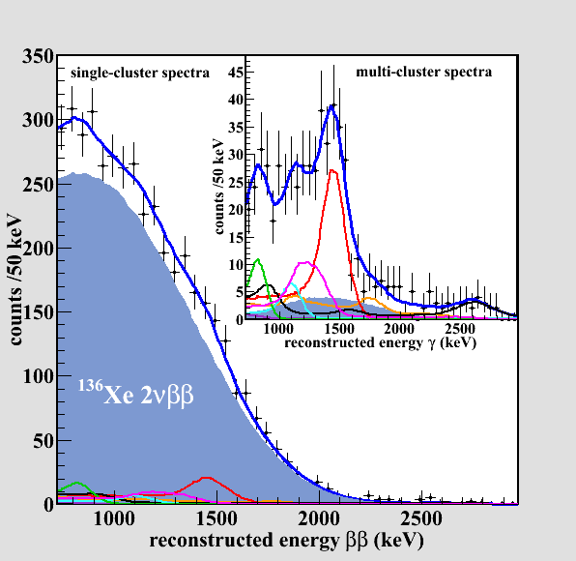
Figure 1
The energy spectrum of events reconstructed as single depositions in the TPC, where the blue fill is the fitted signal due to two-neutrino double beta decay. Prominent contributing backgrounds are fitted and shown as colored curves (black : ²³²Th, purple : ⁶⁰Co, red: ⁴⁰K). The inset gives the same for the case of multiple deposition events, which are overwhelming due to backgrounds. (In both cases the grand total fit is the blue curve).

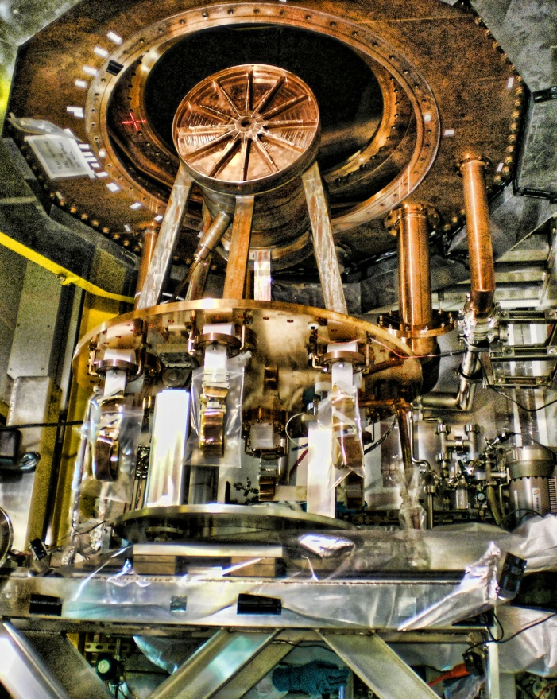

The cylindrical high-radiopurity copper vessel of the EXPO-200 TPC, attached to the cryostat inner “door” and including conduits for xenon and signal cables, is shown here during installation underground at WIPP. The vessel, which during operation contains the TPC immersed in liquid xenon, has a diameter of roughly 50 cm.

